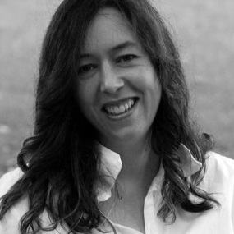
A note from me
Hello, and thank you for your interest in Norwex.
I thought it might help if I share a little of my story with you.
I am a mother of three (mostly!) lovely children, aged 9, 12 and almost 17, with my husband Chris who is also a fan of Norwex! I’ve been a consultant since January 2014, a team leader since October the same year, and Sales Leader since September 2015.
I’m part of a large Norwex team called The Gems, led by the top leader in the Australia & New Zealand (Linda Pearce, who is the only Senior Vice President Sales Leader we have so far), and have my own growing team of consultants around Australia and New Zealand.
Some of my team mostly buy for themselves, selling to their family, friends, and work colleagues, while others have their own business and sell Norwex through parties and fundraisers like I do.
Let me admit straight out that I am not a fan of cleaning, but I do love these products, partly because they make cleaning so much quicker and easier! I went to my first party back in October ’13, starting out a total sceptic. But, I was blown away by how well the cloths worked, and booked my own party to see more (and so my friend, the previous host, could get her mop!). I was again blown away by how much I received in free host gifts, and got completely sold on using the products.
I also loved that these products help people to reduce the nasty chemicals they are using in their homes and putting down the drain – in fact, that was what first appealed to me – so pretty soon I was paying my small fee of (then) $59.95 to get the $200 start-up kit, and starting my own business!
I LOVE that my job now is to help others to create “safer havens” of their homes, AND help others develop whole new careers, or get some pocket money, or develop a hobby and make some friends - and also that I can do it around my kids’ commitments, school holidays and other events.
If you are thinking of joining, I will be here to support you in whatever your journey may be. I certainly don’t know everything about this business, but I am dedicated to helping those I in my team to make the most of the opportunity as it works for you.
And, I am supported by an amazing team of leaders above me, from my own “upline” Rachelle Potter (Senior Executive Sales Leader) all the way up to Linda Pearce in Queensland. I have been so impressed by the supportive people in Norwex, and love to pass on the benefits I have received.
There is heaps of training available, both locally and online. There are many existing training resources online, plus webinars every month.
I hope that helps a little. Feel free to contact me with any questions or concerns. Also for those with partners, I know my husband was very interested in how it all works, and I am more than happy to chat with you together or provide you with any extra information you need.
Sincerely,
Kirsten
Mobile: 0402 445 578
Email: Kirsten@sustainablesuburbia.net
Norwex website & store: http://kirstenmcculloch.norwexbiz.com.au
Blog: http://SustainableSuburbia.net

